Executives pitch for venture capital
BY CARRIE MASON-DRAFFEN
Newsday Staff Writer
June 9, 2006

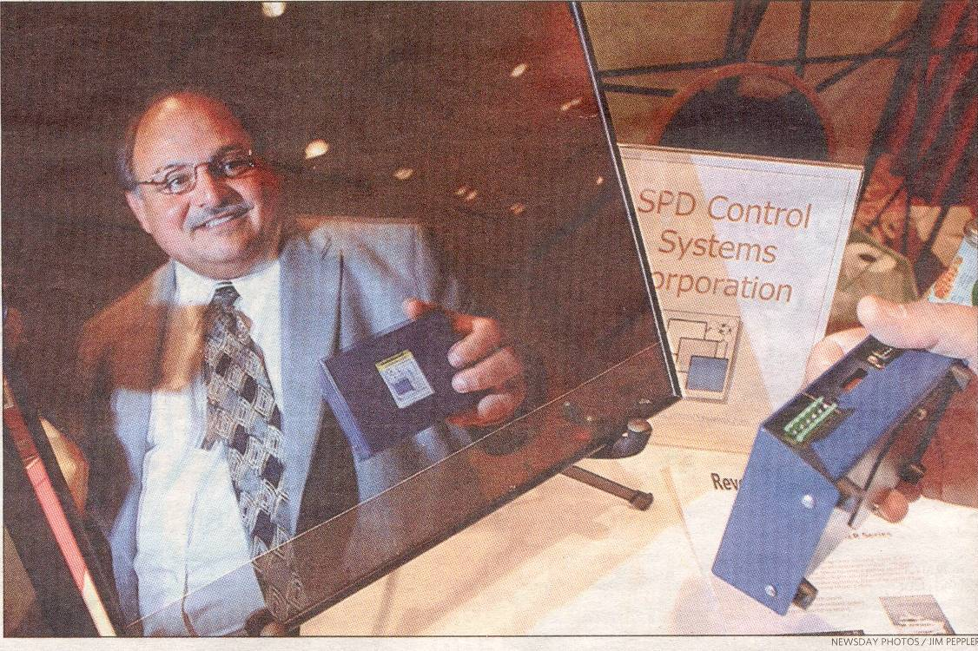
Some executives who had the ultimate homework assignment faced grading day at a Melville forum yesterday. On a Huntington Hilton dais, each had 12 minutes to persuade venture capitalists and angels to invest in their companies. The gathering was the 12th annual LI/NY Metro Capital Forum, a high-stakes game of financing with no grading curve.
Jay Moskowitz was one of 16 presenters, primarily from Long Island and New York City. Moskowitz is founder and chairman of 8 month-old SPD Control Systems Corp. in Stony Brook. The company wants $5 million to help make and market a centralized electronic system that darkens special windows in cars and offices when the sun is blazing. With financing, "what you can [otherwise] accomplish in five years you can accomplish in one," he said in an interview.
The Long Island Capital Alliance, a 22-year-old group that promotes local businesses and sponsored the event, expected 50 to 75 investors in the audience. Leo A. Guthart, the keynote speaker and head of Topspin Partners, a Long Island venture fund that manages $213 million, said his firm looks for companies that present ideas concisely and offer high rates of return, among other factors. He believes the Island is underfunded by venture capitalists because of a shortage of high-tech talent. "We have a ways to go," he said in interview. "But we are getting somewhere.
For some companies, the forum represents their best shot at financing. Rising interest rates make bank loans and debt financing prohibitive, said presenter Jonathan M. Steiman, founder of Auricle Hearing Enhancement Centers in Manhattan. He was seeking up to $1.5 million to open a store that would help bring branding and a spa-like atmosphere to the hearing-aid industry. "The market is ripe for a dominant player to come in and build a brand," he said.
Last year, five of 17 entrepreneurs received funding, a forum spokeswoman said. As in the past, this year's entrepreneurs may have to be patient. Although a deal was done on the spot last year, the spokeswoman said, decisions can take from two weeks to a year. And the bar is high. Paul R. Homer, vice president of Northwood Ventures in Syosset, said his fund invests in about 2 percent to 3 percent of every 100 to 200 companies it meets with.

